**PROJECT DEVELOPMENT PHASE**

**DELIVERY OF SPRINT-3**

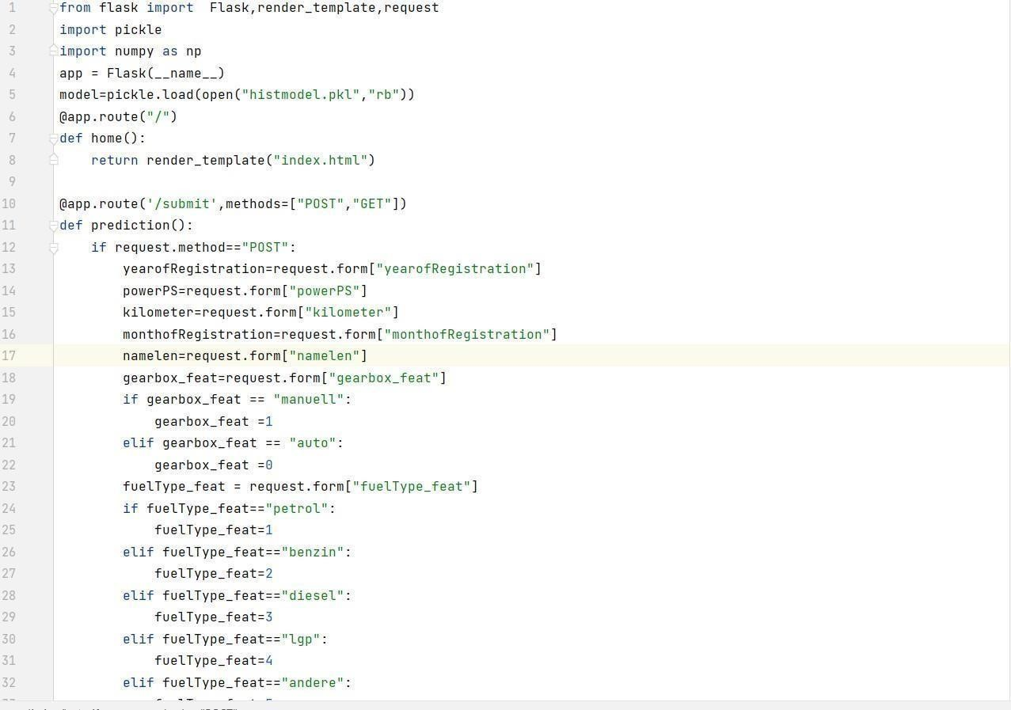

|  |  |
| --- | --- |
| DATE | 8 November 2022 |
| TEAM ID | PNT2022TMID36315 |
| PROJECT NAME | Car Resale Value Prediction |
| MAXIMUM MARK | 4 Marks |

* **Flask framework** 

* **HTML design code** 

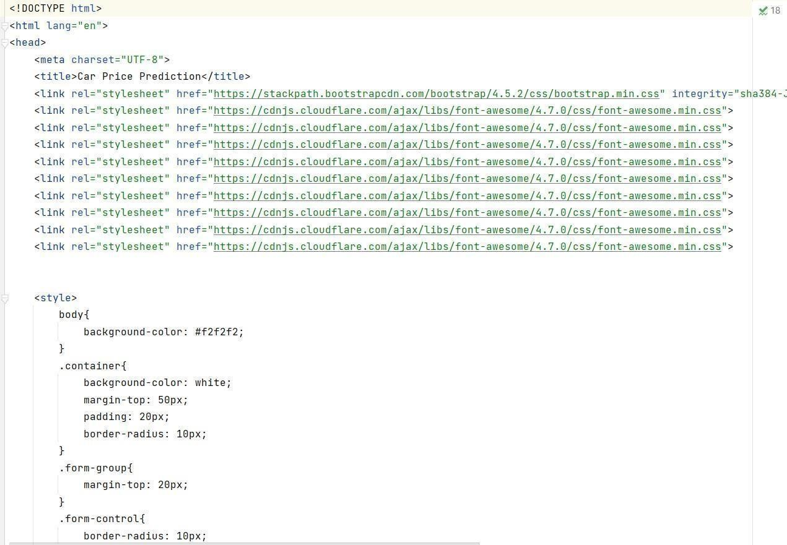

* **Application webpage** 

